**物理講演会 Report01**

「LHC実験10年 - 今後の方向性」

山崎祐司 教授（神戸大学）

In this lecture, 山崎先生 mainly introduce the recent 10 years research in LHC, he first did some summary about how the LHC discovered Higgs and how it decay by several channels.

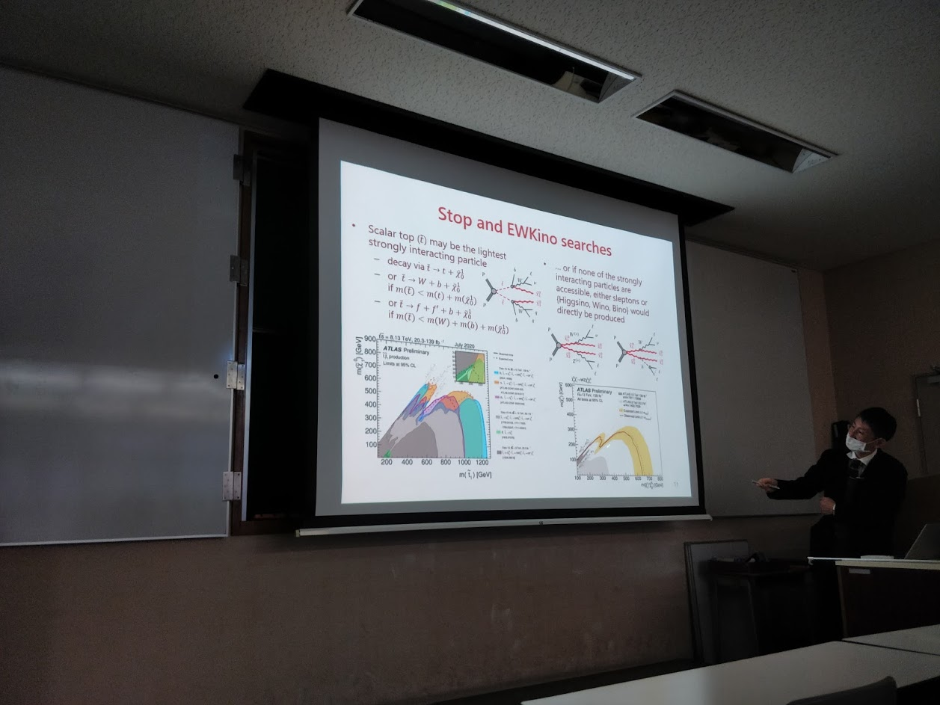

The main subject of LH-LHC will be searching for the muon pair production from Higgs particle, it is clean but cross section is rather small, so it requires high luminance which can be achieved after the upgrade of LHC.

And in the last 10 years, LHC also did some other projects like the extending search region for BSM physics. And precision measurement on top and electroweak.

And another topic was top quark. The most common is production of a top–antitop pair via strong interactions. In a collision, a highly energetic gluon is created, which subsequently decays into a top and antitop. This process was responsible for the majority of the top events at Tevatron and was the process observed when the top was first discovered in 1995. It is also possible to produce pairs of top–antitop through the decay of an intermediate photon or Z-boson. However, these processes are predicted to be much rarer and have a virtually identical experimental signature in a hadron collider like Tevatron. The top quark is known as a extremely massive quark, so it will decay before form a meson, and the only place can measure the mass of top quark precisely is in LHC, there are mainly three ways to measure the mass of quark: direct measurement, “pole mass” method and using leptons.

And there are also some other projects which will performed on ATLAS in the future such as the new physics which coupled weakly with SM(dark matter

And EFT).

